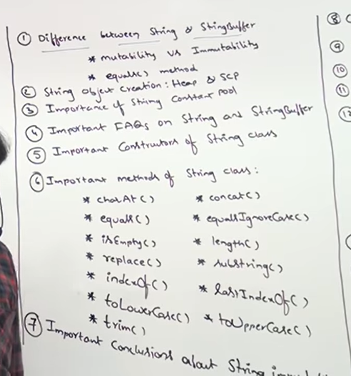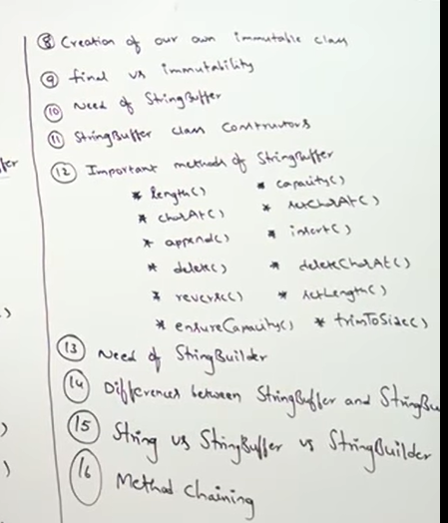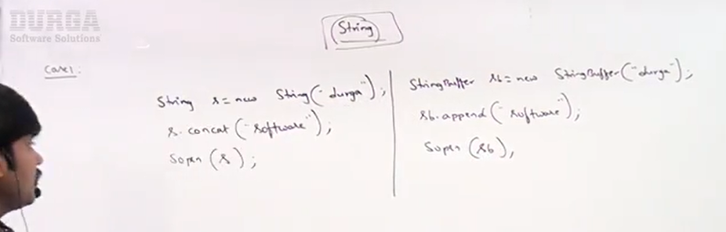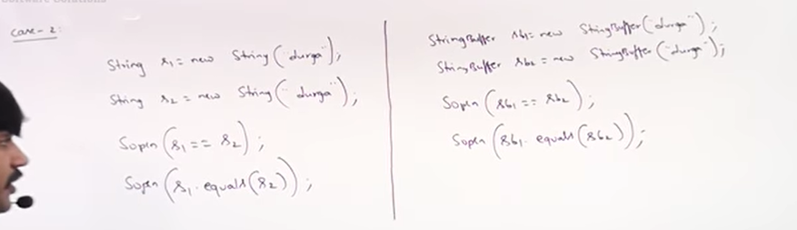import java.io.\*;

import java.util.\*;

public class Solution {

public static void main(String[] args) {

//String

String a=new String("Rani");

String b=new String("Rani");

// String b= a.concat("Chaurasiya");

System.out.println(a==b);

System.out.println(a.equals(b));

//String buffer

StringBuffer ab=new StringBuffer("Rani");

StringBuffer ab1=new StringBuffer("Rani");

// ab.append("Chaurasiya");

System.out.println(ab==ab1);

System.out.println(ab.equals(ab1));

}

}